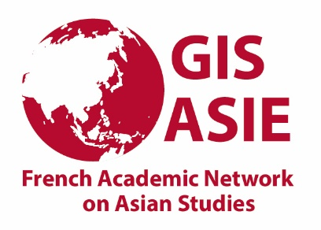

Call for applications for the GIS Asie 2021 exceptional grant for PhD students
(Edited version*)

[*Additional information about the letter of support from the PhD director]

The French Academic Network on Asian Studies (GIS Asie) wants to reinforce its grant system for doctoral students within its scientific perimeter for the year 2021. The ongoing health crisis has indeed had a very acute impact on doctoral research on Asia. The Scientific Council of the GIS Asie wishes to support them by opening a call for applications in 2021, with grants intended to cope with the difficulties of completing the thesis (some sources of income disappeared, delays in accessing to the field, reorientations of the research topic which may have financial consequences ...).

These 2021 GIS Asie grants will be awarded after examination of the application file (see below: list of documents), provided that the conditions of eligibility are met and that the file is sent no later than June 30th. The applications will be examined by an ad hoc committee composed of members of the Scientific Council of the GIS Asie.

Conditions of eligibility:
-to be preparing a PhD thesis in humanities and social sciences on Asia
-to be registered in a French institution or at the Université Libre de Bruxelles for the academic year 2020-2021
-not to benefit from a “contrat doctoral” or CIFRE contract for the academic year 2020-2021 or 2021-2022; civil servants are also excluded.

Amount : The amounts awarded will depend on the overall budget and the argumentation of the request. They will not exceed 3000 euros per application.

Application file (documents should be sent in Pdf format):
- attached form filled in
- a CV including publications (maximal length: recto-verso)
- a document attesting to the registration in PhD thesis for the academic year 2020-2021
- a letter by the doctoral student arguing his or her application, with figures, mentioning fundings (obtained or expected), his or her sources of income, as well as an estimate of his / her needs to complete the work, with a focus on the next six months
- a letter from the PhD supervisor (directeur ou directrice de these) supporting the student's application and informing the ad hoc committee of the reasons for the application, specifying: the means available to the student, the needs that would be met by the grant, the state of progress of the thesis, the projected timetable (and the projected date of completion for doctoral students beyond the 3rd year).

Calendar:
Application deadline: June 30 | Contact: subventions@gis-reseau-asie.org
July: examination of the applications by the ad hoc committee
Announcement of the results by the end of July

Nota bene: A bank account in the name of the candidate in France will be necessary to receive the grant.

Form:

Name, first name:
Date of birth :
Present address :
University:
Research centre of affiliation (with unit code):
Date of first registration:
Title of thesis:
Discipline:
Country(ies) on which the doctoral research is conducted:
Name(s) of thesis director(s):
Have you benefited from a doctoral contract or a thesis grant? If yes, when (dates of start and end)?
Amount requested from the GIS Asie

